***Solution Section* 1.5 – Length of Curves**

***Exercise***

Find the length of the curve  from *x* = 0 to *x* = 3.

***Solution***





















***Exercise***

Find the length of the curve  from *x* = 0 to *x* = 4.

***Solution***





















***Exercise***

Find the length of the curve  from *y* = 1 to *y* = 9.

***Solution***



1.  ***√***
2.  ***√***





































***Exercise***

Find the length of the curve  from *y* = 2 to *y* = 3.

***Solution***

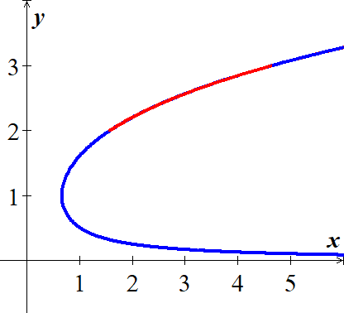

1.  ***√***
2.  ***√***

































***Exercise***

Find the length of the curve 

***Solution***



|  |  |
| --- | --- |
| 1. ***√*** | 1. ***√*** |







***Exercise***

Find the length of the curve of 

***Solution***



|  |  |
| --- | --- |
| 1. ***√*** | 1. ***√*** |









***Exercise***

Find the length of the curve of 

***Solution***



|  |  |
| --- | --- |
| 1. ***√*** | 1. ***√*** |





 

***Exercise***

Find the length of the curve of 

***Solution***



|  |  |
| --- | --- |
| 1. ***√*** | 1. ***√*** |









***Exercise***

Find the length of the curve of 

***Solution***



|  |  |
| --- | --- |
| 1. ***√*** | 1. ***√*** |









***Exercise***

Find the length of the curve of 

***Solution***



|  |  |
| --- | --- |
| 1. ***√*** | 1. ***√*** |











***Exercise***

Find the length of the curve 

***Solution***



















***Exercise***

Find the length of the curve 

***Solution***



|  |  |
| --- | --- |
| 1. ***√*** | 1. ***√*** |









***Exercise***

Find the length of the curve 

***Solution***

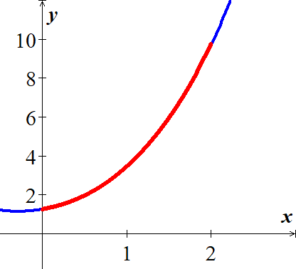























***Exercise***

Find the length of the curve 

***Solution***



























***Exercise***

Find the length of the curve 

***Solution***























 

 









***Exercise***

Find the length of the curve 

***Solution***



|  |  |
| --- | --- |
| 1. ***√*** | 1. ***√*** |









***Exercise***

Find the length of the curve 

***Solution***



|  |  |
| --- | --- |
| 1. ***√*** | 1. ***√*** |









***Exercise***

Find the length of the curve 

***Solution***



|  |  |
| --- | --- |
| 1. ***√*** | 1. ***√*** |













***Exercise***

Find the length of the curve 

***Solution***



|  |  |
| --- | --- |
| 1. ***√*** | 1. ***√*** |













***Exercise***

Find the length of the curve 

***Solution***



|  |  |
| --- | --- |
| 1. ***√*** | 1. ***√*** |









***Exercise***

Find the length of the curve b

***Solution***



|  |  |
| --- | --- |
| 1. ***√*** | 1. ***√*** |





 

***Exercise***

Find the length of the curve 

***Solution***



|  |  |
| --- | --- |
| 1. ***√*** | 1. ***√*** |







***Exercise***

Find the length of the curve 

***Solution***



|  |  |
| --- | --- |
| 1. ***√*** | 1. ***√*** |









***Exercise***

Find the length of the curve 

***Solution***



















***Exercise***

Find the length of the curve 

***Solution***











***Exercise***

Find the length of the curve 

***Solution***



|  |  |
| --- | --- |
| 1. ***√*** | 1. ***√*** |







***Exercise***

Find the length of the curve 

***Solution***



|  |  |
| --- | --- |
| 1. ***√*** | 1. ***√*** |







***Exercise***

Find the length of the curve 

***Solution***



|  |  |
| --- | --- |
| 1. ***√*** | 1. ***√*** |











***Exercise***

Find the length of the curve 

***Solution***



















***Exercise***

Find the length of the curve 

***Solution***



















***Exercise***

Find the length of the curve 

***Solution***

















***Exercise***

Find the length of the curve 

***Solution***

















***Exercise***

Find the length of the curve . Check your answer by finding the length of the segment as the hypotenuse of a right triangle.

***Solution***



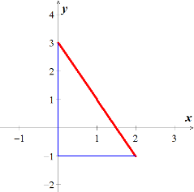

















***Exercise***

Find a curve through the origin in the *xy*-plane whose length from *x* = 0 to *x* = 1 is 

***Solution***



 





 



***Exercise***

Confirm that the circumference of a circle of radius *a* is .

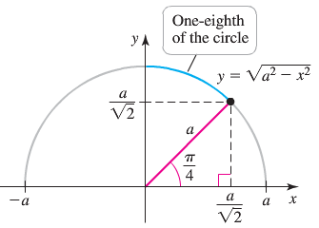***Solution***



 but 





Let’s compute the length of  of the circle on 











***Exercise***

The profile of the cables on a suspension bridge may be modeled by a parabola. The central span of the Golden Gate Bridge is 1280 *m* long and 152 *m* high. The parabola  gives a good fit to the shape of the cables, where , and *x* and *y* are measured in *meters*. Approximate the length of the cables that stretch between the tops of the two towers.

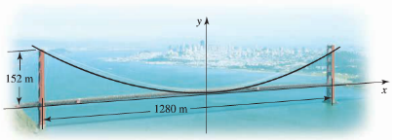

***Solution***



 







***Exercise***

Electrical wires suspended between two towers form a caternary modeled by the equation



Where *x* and *y* are measured in *meters*. The towers are 40 *meters* apart. Find the length of the suspended cable.

***Solution***





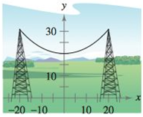 











***Exercise***

A barn is 100 *feet* long and 40 *feet* wide. A cross section of the roof is the inverted caternary . Find the number of ***square feet*** of roofing on the barn.

***Solution***



|  |  |
| --- | --- |
| 1. ***√*** | 1. ***√*** |

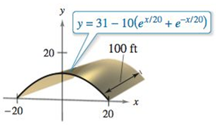





∴ There are  of roofing on the barn

***Exercise***

A cable for a suspension bridge has the shape of a parabola with equation . Let *h* represent the height of the cable from it lowest point to its highest point and let  represent the total span of the bridge.

Show that the length *C* of the cable is given by 

***Solution***





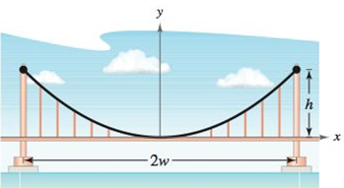At 





∴ By symmetry:



***Exercise***

Find the total length of the graph of the astroid 

***Solution***





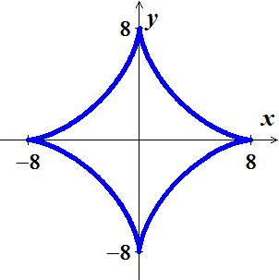 

















***Exercise***

Find the arc length from  clockwise to  along the circle 

***Solution***



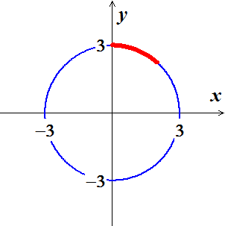











***Exercise***

Find the arc length from  clockwise to  along the circle . Show that the result is one-fourth the circumference of the circle.

***Solution***

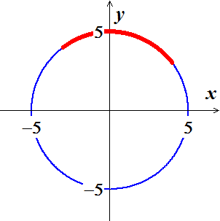













***Exercise***

 between  and  that



Use any means to approximate the value of *b* for which the curve has length 2.

***Solution***

***Given***: 













Using Mapple:





